User Guide: Running the Data Visualization Dashboard

For Windows Users:
Step 1: Download and Extract
- Download the ZIP file of the project.
- Right-click on the zip folder and click on “Extract All…” and save it somewhere easy to find, like C:\DashboardProject\
- Navigate to the “305Project” folder
- This folder should contain the following:
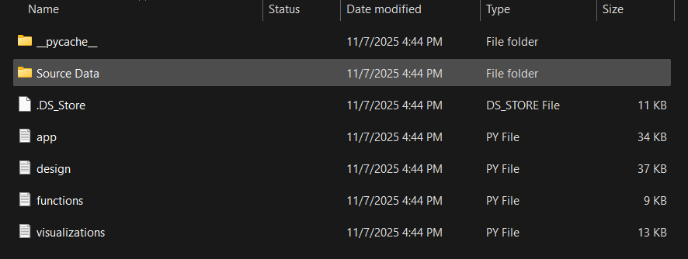

Step 2: Open Command Prompt
- Press Start, type “cmd” and Enter.
- Navigate to your project folder:
- cd C:\DashboardProject\305Project

Step 3: Check Python Version
Run:
python --version
If you see Python 3.9 or higher, continue.
If not:
- Download the latest version from https://www.python.org/downloads/
- During install, check “Add Python to PATH”
Verify again:
python --version

Step 4: Install Required Libraries
Install all necessary packages:
pip install dash plotly pandas textblob nltk
python -m textblob.download_corpora

This installs:
- Dash & Plotly: for the interactive dashboard
- Pandas: for data handling
- TextBlob: for sentiment analysis
- re (Regular Expressions): built into Python, used for text pattern matching and cleaning (no separate installation needed)

Step 5: Run the App
To start the dashboard:
Type and enter: python app.py
When it shows:
Running on http://127.0.0.1:8050/
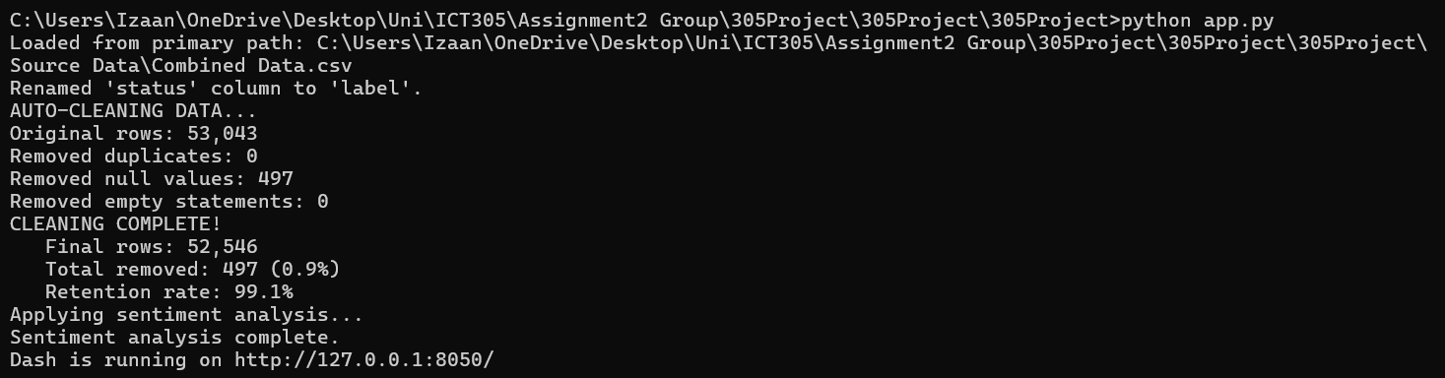
Dashboard should open up on your default browser in a few seconds!
Another way to open the dashboard is to run http://127.0.0.1:8050/ on your browser.
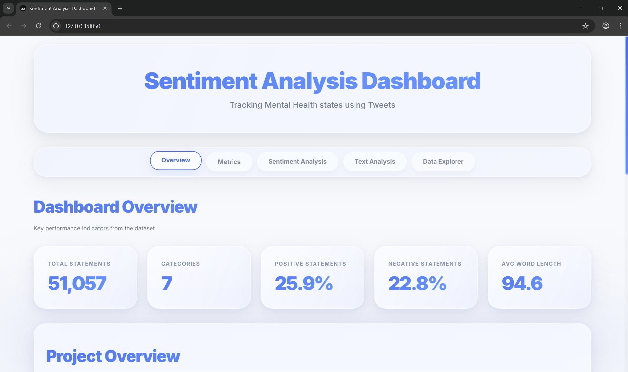

For MacOS Users:
Step 1: Download and Extract
- Download the ZIP file.
- Extract it to your Desktop:
- ~/Desktop/DashboardProject
Folder contents:
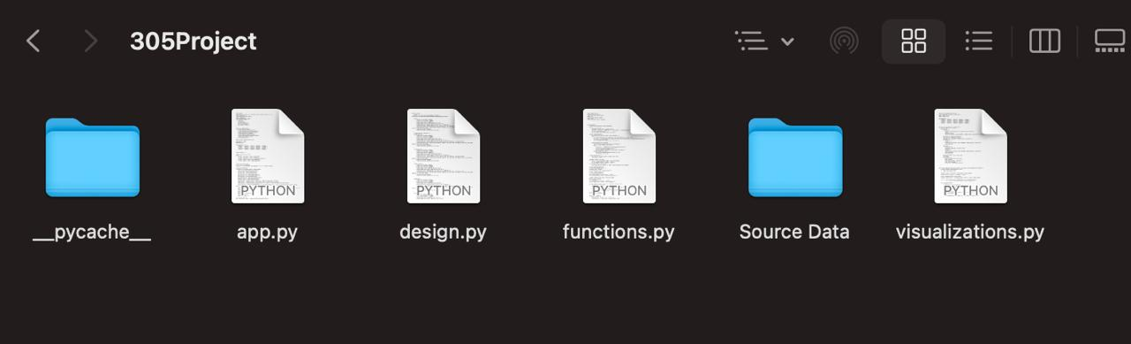

Step 2: Open Terminal
Press Command + Space, type “Terminal” and Enter, then:
Move to the project file location,
cd ~/Desktop/DashboardProject

Step 3: Check Python Version
Run:
python3 --version
If you see Python 3.9 or higher, continue.
If not, download and install the latest version from https://www.python.org/downloads/.
Verify again:
python3 –version

Step 4: Install Required Libraries
pip3 install dash plotly pandas textblob nltk
python3 -m textblob.download_corpora
This installs:
- Dash & Plotly: for the interactive dashboard
- Pandas: for data handling
- TextBlob: for sentiment analysis
- re (Regular Expressions): built into Python, used for text pattern matching and cleaning (no separate installation needed)

Step 5: Run the App
python3 app.py
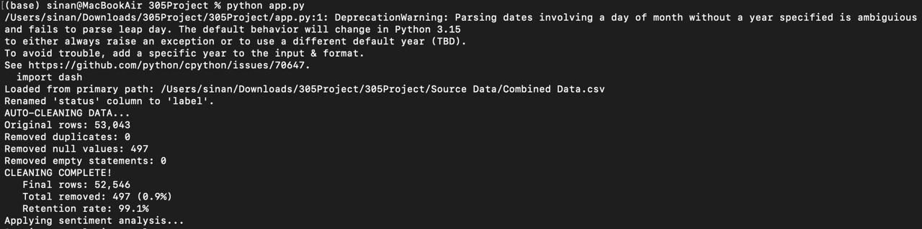
You’ll see:
Running on http://127.0.0.1:8050/
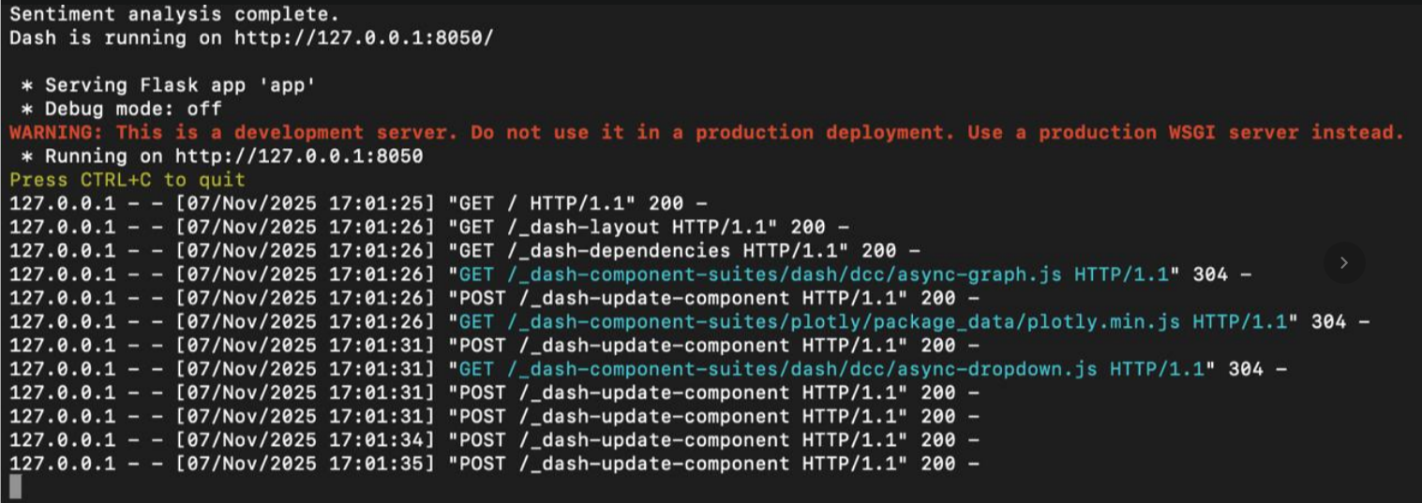
Copy that URL and open it in your browser and the dashboard will appear in a few seconds!

For Linux (Ubuntu / Debian)
Step 1: Update & Install Python
Open Terminal and run:
sudo apt update
sudo apt install python3 python3-pip -y
Check Python version:
python3 --version
If it’s 3.9 or above, continue.

Step 2: Download and Extract
Copy the ZIP file to your Home directory.
Right-click and click on “Extract Here”.
Once extracted, click on the extracted folder and navigate to “305Project”
This folder contains the following:
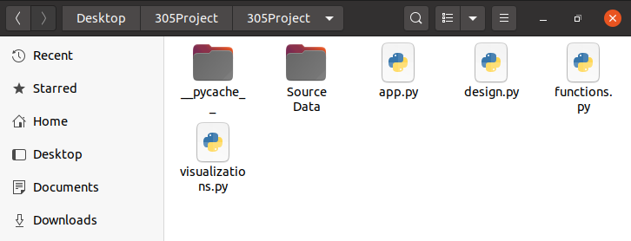

Step 3: Navigate to the Project Folder
cd ~/Desktop/305Project

Step 4: Install Required Libraries
pip install dash plotly pandas textblob nltk
python3 -m textblob.download_corpora
This installs:
• Dash & Plotly: for creating the interactive web dashboard and charts
• Pandas: for data loading, cleaning, and manipulation
• TextBlob: for performing sentiment analysis (polarity and subjectivity)
• re (Regular Expressions): built into Python, used for text pattern matching and cleaning (no separate installation needed)

Step 5: Run the Dashboard
python3 app.py
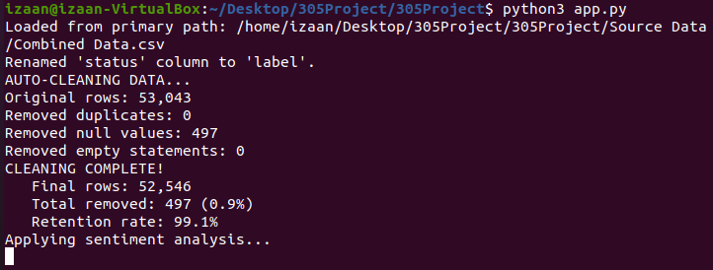
You’ll see:
Running on http://127.0.0.1:8050/
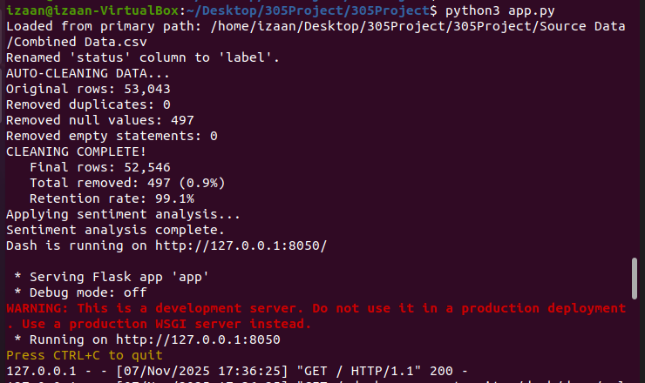
Copy that link URL and open it in your browser and the dashboard will appear in a few seconds!

